**Program Screens/Walkthrough**

The following will show images of the system and a user walkthrough of how to use the different forms.

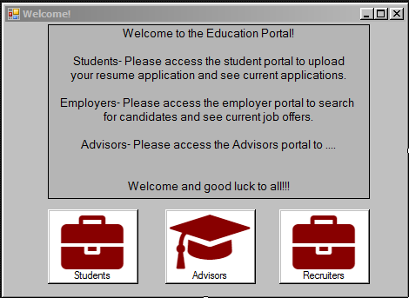

User will choose which system is desired whether they are a student, advisor, or recruiter.

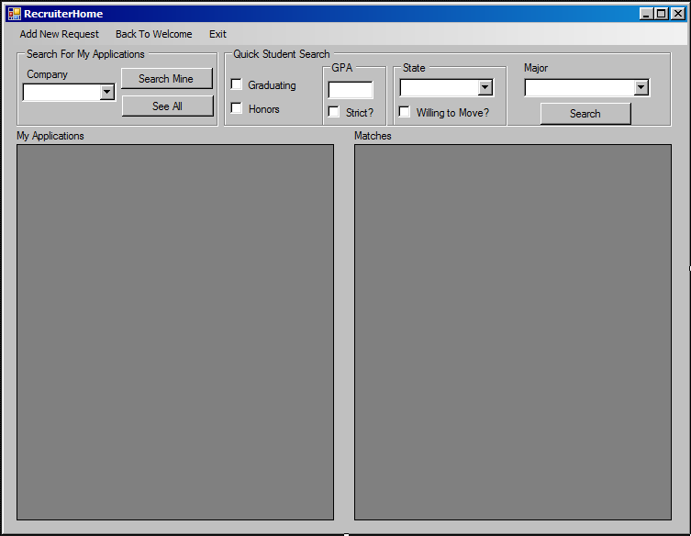

The recruiter option will bring them to this screen which offers multiple options. A recruiter can enter their company and search for the current applications they have in the system. The data grid displays their job applications in the system. If the recruiter clicks on the data grid it will find matching student applicants and display them in the adjacent data grid to the right. The recruiter can also search by using the “Quick search” fields and find a potential student by using the above search criteria. Also, the recruiter can create a new application by clicking on the menu bar “Add new application”.

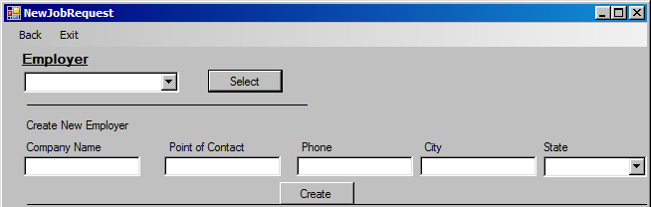

After clicking on “add new application” this screen will pop up. The form will allow the recruiter to create a new company in the system.

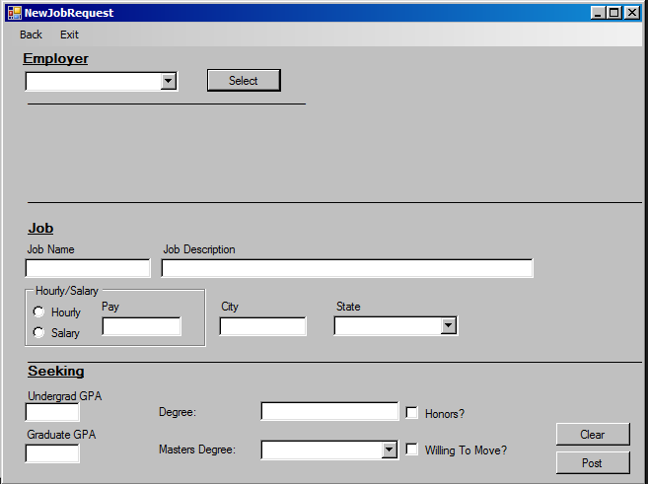

If the employer is selected in the drop down box instead then the bottom part of the form will show up. The recruiter can then make a job request based on the company that was selected.

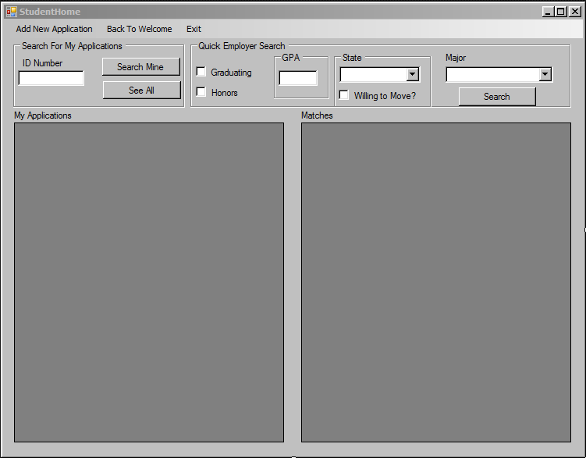

(Assuming user is at home screen)

If the user is a student then they will click on student at the home screen. The student can then search for their current applications in the system, searching by their id number. Search results will appear in the data grid below. Also, if the students want to search for companies that are looking for a certain criteria then they can insert this in the “quick search” area.

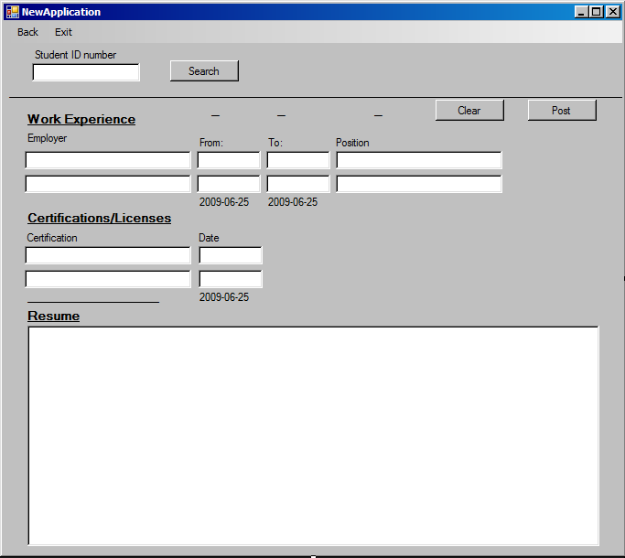

When the student clicks on a job posting it will bring them to this screen. The student will enter their ID, enter in the designated fields and then press post. They have now applied to the company.

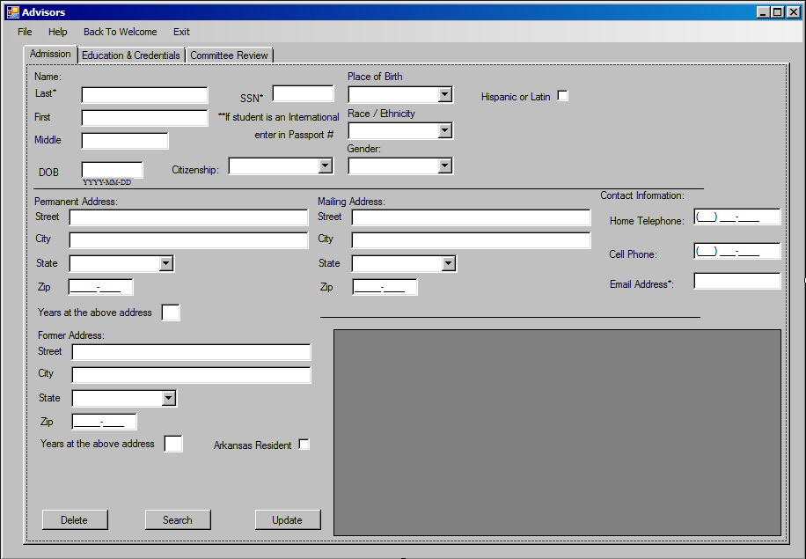

Figure 1.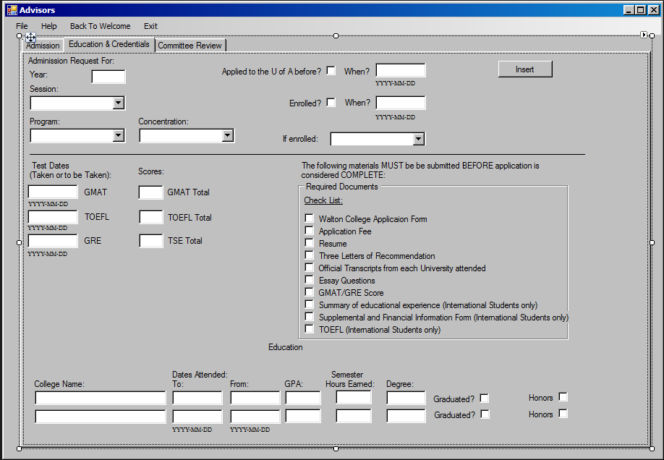

Figure 2.

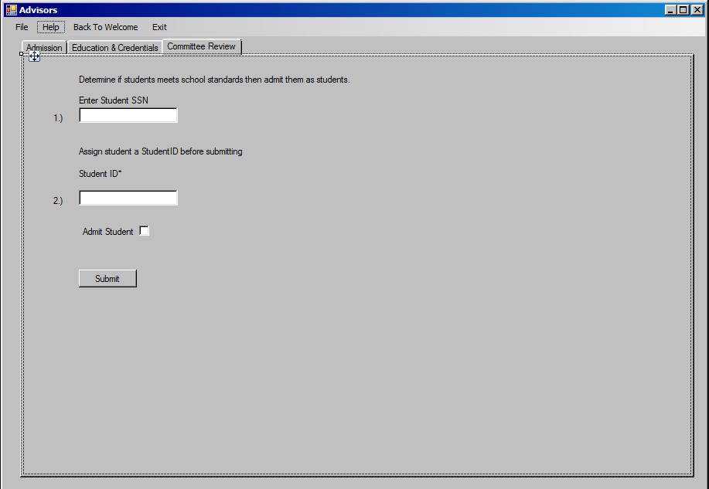

Figure 3.

(Assuming user is at home screen)

The user will click on advisor to arrive at this screen. The advisor will then input the student application information into this form. Some fields are required, so will not be able to be submitted if nothing is entered (Fig 1). When the advisor is finished with Fig. 1 they will click on the next tab to arrive at Fig. 2. The advisor will also input the applicant information on this form and when everything’s entered, press insert. Assuming theirs a decisional process taking place in the department in order to admit a student. After the advisor is notified of the decision they will continue to Fig.3. An advisor will then enter the designated students SSN and generate a student ID. If the decision is to admit the student then check the check box and click submit. The student has now been admitted.

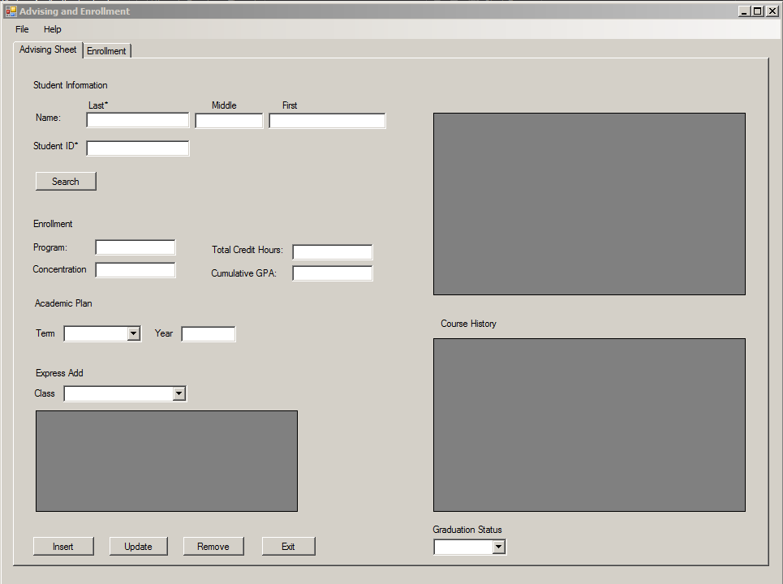

The advising screen is reached through the home screen by clicking on advisors. The scenario is that the student comes into the advisors office and gets course recommendations. After the advisor and student deliberate on this topic, the advisor will enter in the student’s information. An advisor will search by the student name or student ID. If more than one student show in the system the advisor will scroll and select the correct student in the data grid. The selection of the data grid will pull some the student’s record information into several fields. Next, the advisor will select the classes from the drop down box which adds to the data grid and enter in the term and year. Also, after all the courses have been added the advisor if needed can select the course in the data grid and remove it. When the advisor is sure of the desired course the insert button when enroll the students into the courses.

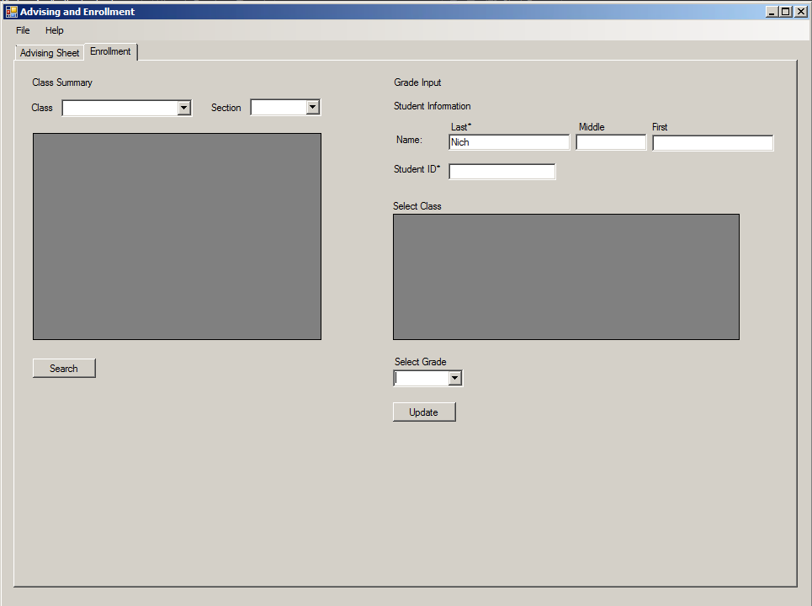

The next screen above is for the instructor to come in and assign grades to the student’s courses. The instructor can view all the courses in the class summary area. If the instructor selects a class it will populate the adjacent data grid. The instructor will then select a grade for the particular student that was populated into the text fields. Next, the instructor clicks update to submit grades for the courses the student is enrolled in.